**Personal Information**

Name: Charlie Nitschelm

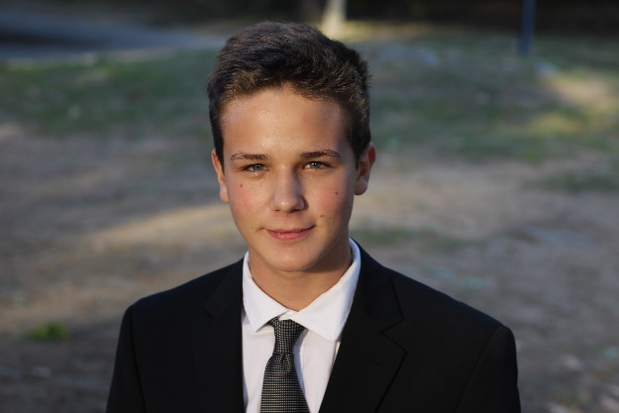Date of Birth: April 30th 1998

Place of Birth: Portsmouth, NH USA

Citizenships: United States of America

**Contact Information**

School Address: GSS Box 12411, Durham NH, 03824 USA

Permanent Address: 384 Peverly Hill Road,

Portsmouth NH, 03801 USA

Cell phone: (603) 923-9079

Email Address: cjn1012@wildcats.unh.edu

**Education**

University of New Hampshire

B.S. in Mechanical Engineering

Physics Minor

Honors Program

Cumulative GPA: 3.92

Expected Graduation: May 2020

**Related Course Work**

Chemical Principals for Engineers Statics

Differential Equation with Linear Algebra Thermodynamics

Multi-Dimensional Calculus Introduction to Material Science

Physics 1 – Mechanics Astronomy

Physics 2 – Electricity and Magnetism

**Experiences**

**Research Experience**

**UNH Institute for the Study of Earth, Oceans, and Space May 2017 – August 2017**

*Researcher*

* Used Python to conduct a systematic search of the COMPTEL data for evidence of polarization from solar flares
* Organized necessary data sets and developed tools that will be needed for analysis
* Using the COMPTEL field-of-view, determined the number of source and background counts for that

event, and then used simulations to estimate the polarization sensitivity for that event

* Created a systematic analysis of all gamma ray bursts that took place within the COMPTEL field-of-view

**Work Experience**

**Shoal Interactive, LLC January 2017 – present**

*Business and Marketing Intern*

* Attend weekly meetings to decide business and product decisions with the team
* Assist with the applications user interface and administrative writing
* Lead major marketing campaigns to neighboring towns for the release of our Coupler’s alpha

**Engineering Experience**

**UNH Students for the Exploration and Development of Space Mar. 2017 – present**

*Co-Founder, CTO, Head of Rocket Propulsion*

* Lead overall managerial duties of the organization including running all meetings and overseeing the goals of the organization
* Foster a learning environment for all and manage all outreach and networking events
* Head the design and manufacturing for the rocket propulsion team, which includes a two-stage solid rocket booster
* Manage all tech leads to create a high-altitude rocket to participate in the University Student Rocketry Competition in September. 2018

**UNH LunaCats Sept. 2016 – May 2017**

*Electrical Team Member*

* Designed, fabricated and coded a robotic excavator to compete in NASA’s Robotics Mining Competition
* Assembled and tested the electronics box so the rover can successfully compete at Kennedy Space Center for the 2017 NASA sponsored Robotics Mining Competition

**UNH Precision Racing Sept. 2016 – May 2017**

*Secretary, Powertrain Engineer*

* Maintained all relations to the college and the surrounding community by providing outreach and an end-of-year banquet to all our supporters
* Assisted the design of the intake system and catch cans

**Portsmouth High School Wire Clippers – FIRST Robotics**

*Team Captain, Mechanical Lead*

* *Lead the overall design of our robot to compete in the 2016 FIRST competition*
* *Managed all outreach events*

**Other Experience**

**STEMbassadors Sept. 2016 – present**

*Member Lead in the Robotics Activity*

* Volunteer in the New Hampshire area to inspire the next generation of engineers and problem solvers
* Run the World of Robotics activity where students can experiment with gear ratios and different wheel choices

**Not Too Sharp Sept. 2016 – present**

*Bass Singer and Beatbox in a Cappella*

* Attend 6 hours of rehearsals every week to prepare and perfect our repertoire.
* Travel to various performances including performing the national anthem for President Obama

**Camp Mi-Te-Na June 2015 – August 2015**

Overnight *Cabin Counselor and Lifeguard*

* Supported the development of young campers ranging in ages from 7-15 years old
* Protected campers swimming in Halfmoon Lake as a certified lifeguard

**Skills**

**Technical Skills**

Microsoft Suite | Solidworks | Python | MATLAB

**Other Skills:**

Project Management | Organizational Leadership | Creativity and Problem-Solving | Communication